(a). Show the course numbers and course names of all courses John Smith took in Spring 2014 along with the grades he received for those courses.

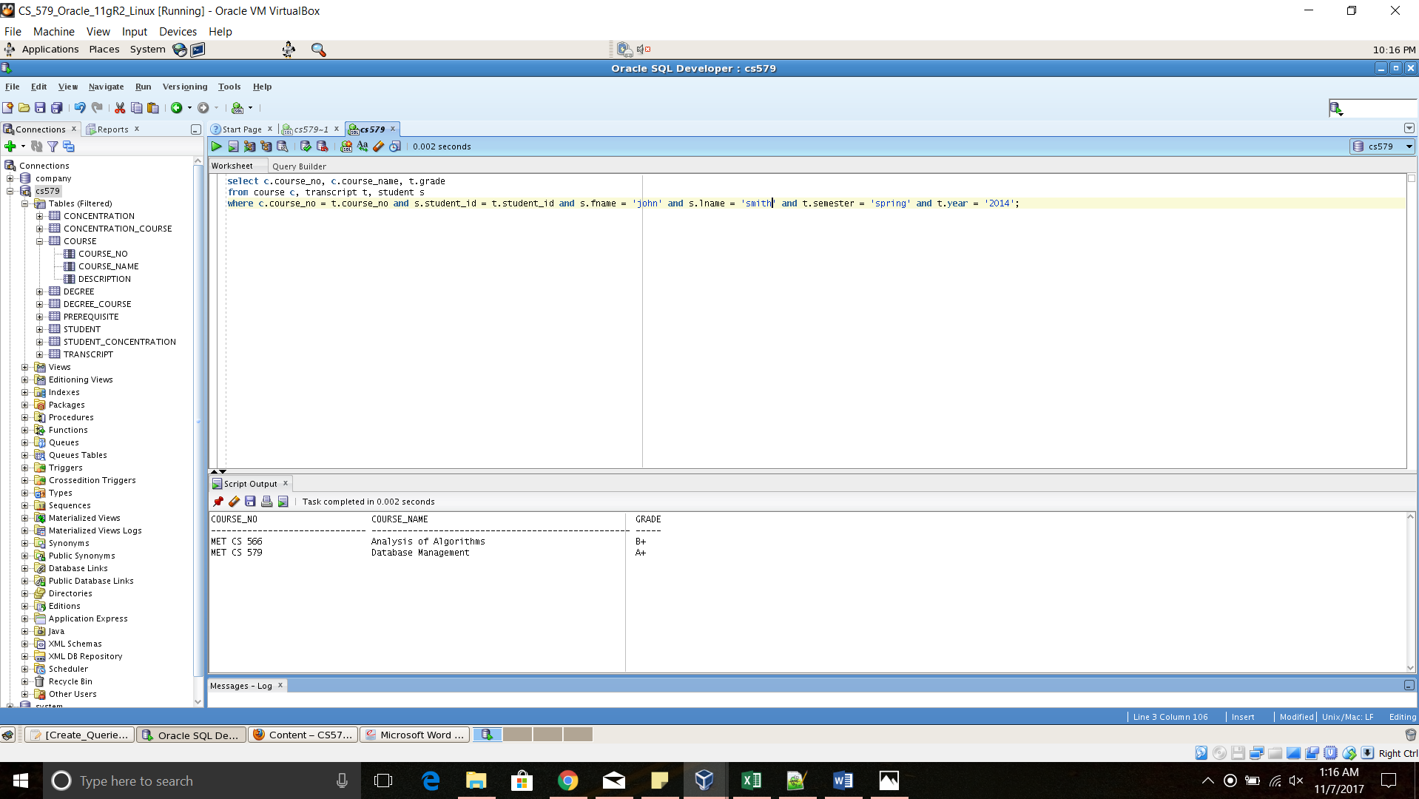

(b). Show the names of all concentrations of MSCS.

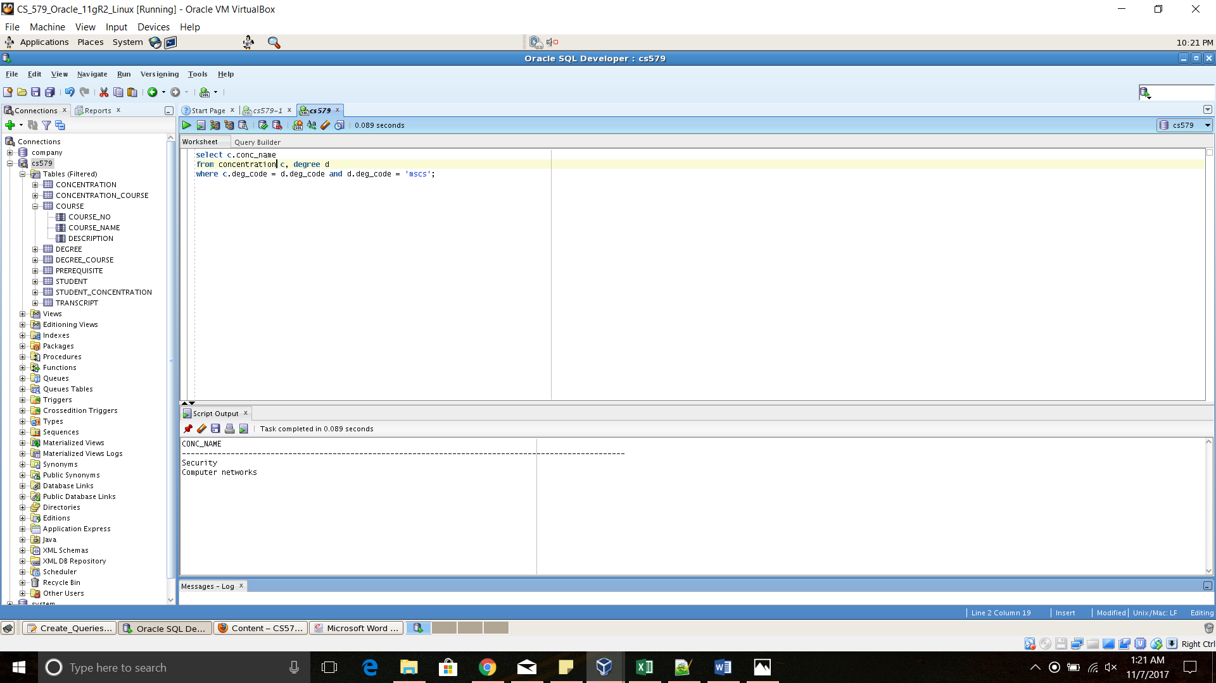

(c). Show the list of courses (course numbers and course names) of all courses for which CS546 is a prerequisite.

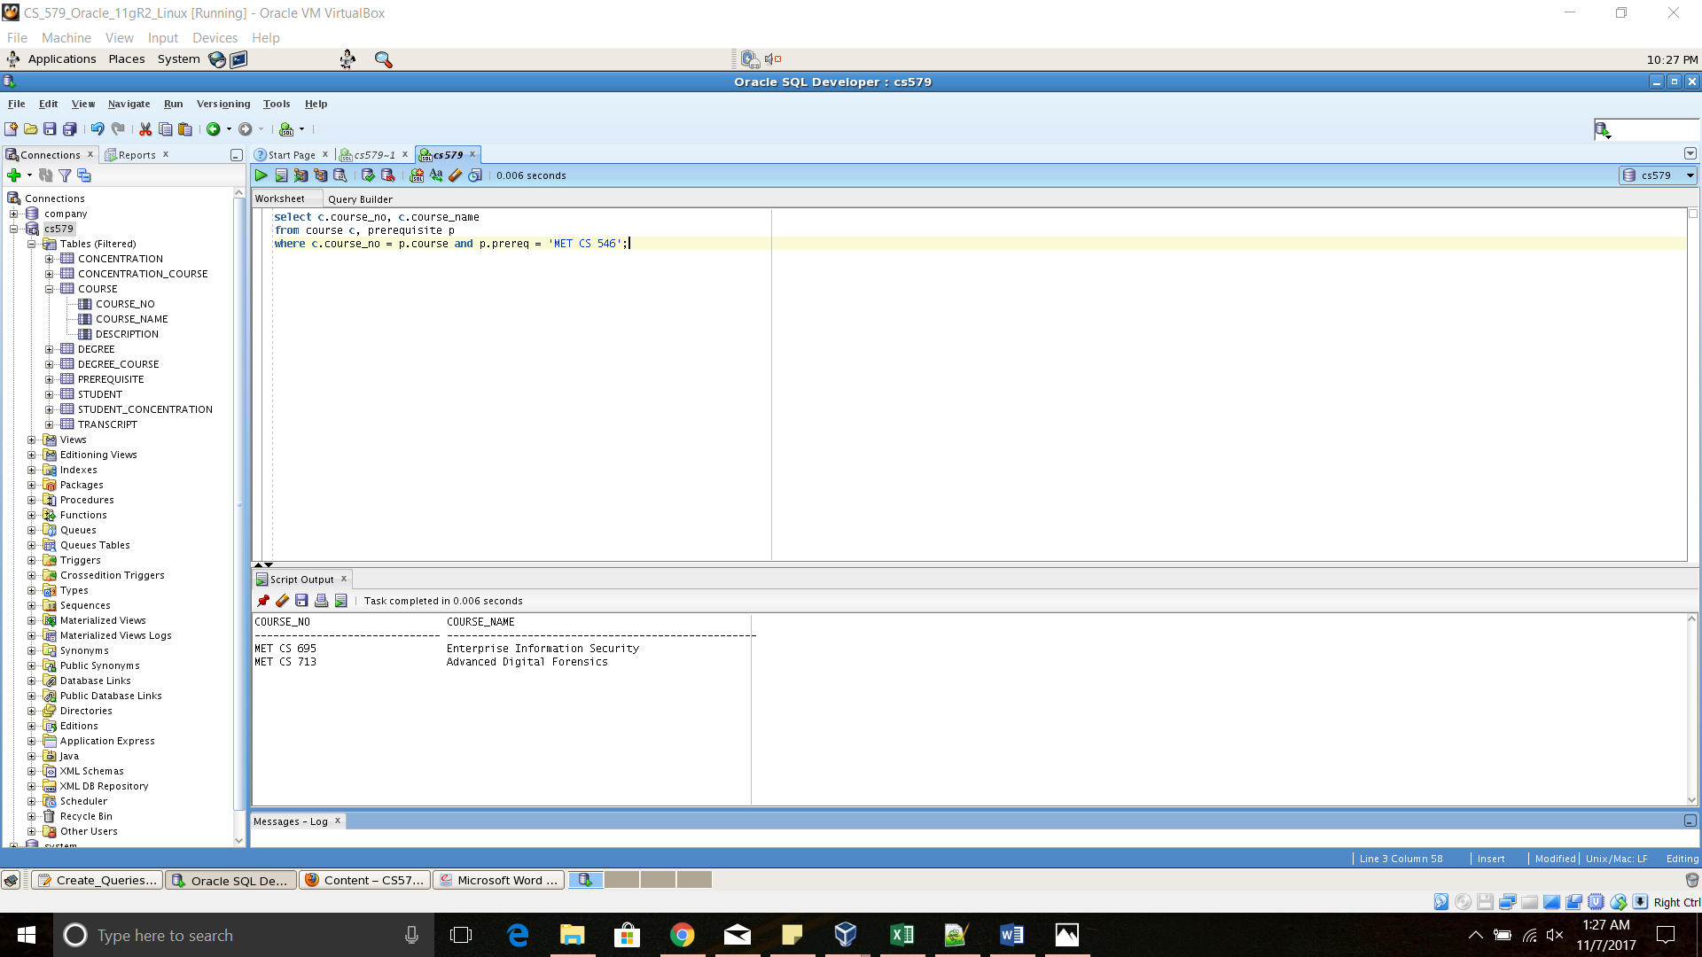

(d). Show the core courses and elective courses of Web Application Development concentration. For each course, show the course number, course name, and the type (core or elective).

